Lab 10: Network Security - Firewalls

Alex Arnold

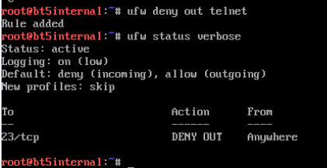

5.1.7